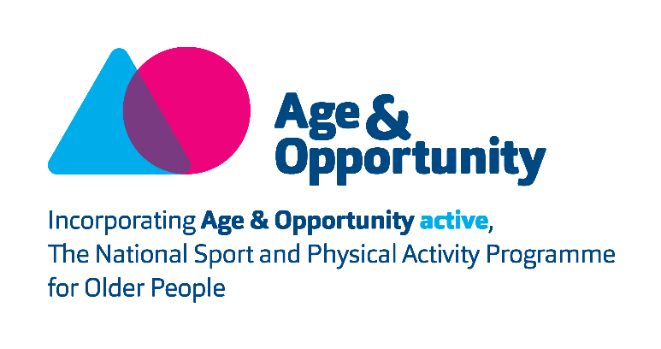

Age & Opportunity
Active Programme FitLine Mentor Volunteer
Application form

Name:

Address:

Telephone:

Email:

Why would you like to volunteer with Age & Opportunity as a FitLine Mentor?

Please tell us about any educational background, work or volunteering experience that would be relevant to this role.

What hobbies, skills, special interests or qualities do you have that may be relevant to this role?

Are you available to volunteer for approximately 3 hours per fortnight?

What day of the week suits you best?

Do you have access to a computer / laptop and the internet?

Referees:
Please supply us with the details of two referees (non-relatives):

Name: | Email:
Address: | Telephone:

Name: | Email:
Address: | Telephone:

Any other comments:

Please return this form to Margaret Roe, HR Manager, Age & Opportunity, Marino Institute of Education, Griffith Avenue, Dublin D09K4P6, or to margaret.roe@ageandopportunity.ie, by 12 noon on Monday the 11th of January 2021. We will be in touch with you after this date to arrange to meet with you virtually to discuss the role.

Please note that Garda vetting will be a requirement of this role.

Signed: ___________________________________

Date: ___________________________________

Data Protection Note: The information contained will not be disclosed to any external party unconnected with this process without your consent, except where necessary to comply with statutory requirements. Internally, the information may be made available to the relevant Managers/Coordinator. You may, at any time, make a request for access to the information held about you as outlined. Should you wish to make any changes or erasures to any of the information stored about you, please contact us.
