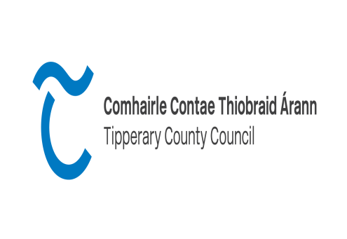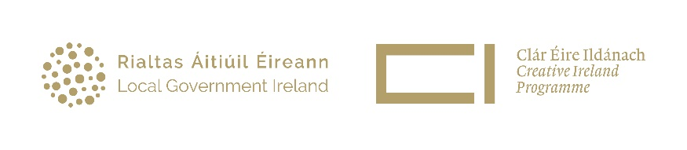
County Tipperary
Creative Ireland Project Award 2023
2023 sees the start of a second five-year Creative Ireland programme. Building on the success of the last five years the new programme will deliver under the framework of a new strategy that will be launched in late February 2023.
The vision of the Creative Ireland Programme 2023 - 2027 is to mainstream creativity in the life of the nation so that individually and collectively, in our personal lives and in our institutions, we can realise our full creative potential thereby promoting individual, community and national wellbeing.
The Creative Ireland Programme will deliver through collaboration and partnership promoting understanding and appreciation of the value of creativity in all its forms whether through arts, culture, heritage, or technology.
The Strategic Priorities for the Tipperary Creative Ireland programme
2023 - 2027 are:
- Our Peoples Creativity - to nurture creativity across the county, foster relationships between creative practitioners & communities, provide opportunity for creative engagement & promote inclusivity in access to participation in cultural activity.
- Our Creative Place - a sense of place is central to our priorities, in terms of knowing our culture, landscape and environment which connects spaces, places and people. Creative Climate Action – to focus on projects which have a climate action element to collectively address these issues.
- Our Creative Economy - the key goal of this priority is to support creative activities which have an economic impact e.g. our creative industries.

Expressions of Interest are sought for projects and initiatives that have the potential to take place during the lifetime of the Creative Ireland programme 2023-2027. To facilitate the maximum potential of funding that will be in place for this programme, project proposals are being sought that fulfil the criteria of the Creative Ireland Programme, especially Pillar 2: Enabling Creativity in every community.
The overall aim of this scheme is to instigate high quality cultural and collaborative projects. Projects should involve a community/ group or clearly benefit the wider community. This project award should encourage new, ambitious and meaningful collaborations between creators/practitioners and communities. Projects that engage directly with a community group are especially welcome. Applications should submit a letter of support from the relevant community organisation. Please note as this fund seeks to encourage new creative collaborations, your proposal should not refer to projects/events already receiving funding from Tipperary County Council or an existing programme or project. Please note we are open to receiving applications for projects which may extend over a year or two which may be of longer-term benefit to the community, however these applications should clearly outline the progress achievable in each year and the funding required for each stage of the project. Tipperary County Council report on an annual basis to Creative Ireland therefore this is necessary for us to adhere to our reporting targets.

Expressions of interest can be submitted under 1 of the following categories:
Category | From | To
A. | €3500 | €5000
B. | €5000 | €10000
C. | €10000 | €15000

Who can apply:
This call is open to all creative practitioners in the county; Artists, Writers, Performers, Crafts people, Historians, Archaeologists, Archivists, Folklorists, Curators.
To be eligible for funding projects must:
Your project must
- Take place in County Tipperary
- Be relevant to the Creative Ireland Strategy
- Engage with the community
- encourage or benefit participation in the Creative Ireland programme and enhance awareness in the local area.
- be in keeping with at least one of the five pillars of the Creative Ireland Programme especially Pillar 2: Enabling creativity in every community.
- be accessible to diverse audiences and participants and is inclusive in theme and approach
- be designed on a realistic financial basis and provide good value for money
- be completed and payment claimed by 27th October 2023. This deadline is to facilitate our drawdown from Creative Ireland and unfortunately is non-negotiable.
In addition the following details must also be supplied
- A full breakdown of costs for undertaking the project including copies of quotations
- A timeline for completion of project.
- The anticipated target audience
- CV of practitioner/artist
- Any additional supports and funding that may be required and have been secured
Items that are excluded from the fund include:
- Capital projects and infrastructural projects
- Equipment
- Spends on alcoholic beverages, food, fines, legal costs, penalty payments, prizes and competitions
- Fuel costs
- Wages and salaries, administration costs.
- Generally, the cost of items for resale are ineligible
Particulars of Funding:
- Grant amounts of between €3,500 to €15,000 will be allocated for the purpose of this scheme.

- Assessment process:
- Applications will be assessed by an assessment panel based on the following criteria:
- Ambition, quality and alignment to the Creative Ireland Pillar 2: Enabling creativity in our community and to our local Creative Ireland priorities
- Capacity, track record and feasibility of completing the project within the timeframe and budget
- Extent of community/audience engagement and overall benefit of the project to the community
- Evidence of collaboration with local communities
- Funding will be allocated based on the recommendations of this panel.
- Successful applicants will receive a letter of offer which will detail all conditions and requirements, this must be signed and returned by the date specified, failure to do so may result in funding being withdrawn and reallocated to another project.
- Due to resource constraints it may not be possible to allocate funding to all projects and eligibility and compliance with these criteria does not guarantee a grant offer.
- A list of successful projects will be published on the Creative Ireland website.
- Deadline for submissions is 4pm on Friday 3rd March 2023 and applications will be assessed by a panel with a view to offers being made as soon as possible thereafter.
Terms and Conditions
Payment is only made after the project is completed. If you receive a grant you will be required to provide the following in order to draw down your grant:
- Proof of payment/receipts for all items including payment to creatives/practitioners.
- A fully completed event report form with metrics required
- A number of high- quality images which have permission for use by Tipperary County Council & Creative Ireland.
- Tipperary County Council and the Creative Ireland Programme must be acknowledged as funders in all publications and media activity. Proof of this is required.
**Failure to comply with any of the above may result in the grant being withdrawn.
The closing date for drawing down funds is Monday 27th October 2023, any funding not claimed by this deadline may be cancelled.
Please note:
Where a grant is allocated to support a particular project, Tipperary County Council will not be responsible for the insurance of that project. Tipperary County Council recommends that project organisers ensure that adequate insurance is in place prior to the commencement of the project.
Tipperary County Council will not be responsible for any approvals, planning permissions, licences or consents needed for the project; it is the responsibility of the applicant/organiser to ensure these are in place.
Please note that public art projects such as murals, sculptures etc generally require planning permission, please include planning reference numbers or details of contact with the Planning Department in such instances. Permission/consent of landowner should be provided where relevant.
Applicants intending to work with or provide programmes for children or young people must provide an up to date child protection policy as a supporting document.
How to apply:
Please complete and sign the attached application form. Applications should be marked ‘Tipperary Creative Ireland Projects Award 2023’ and can be submitted preferably by email to heritage@tipperarycoco.ie or alternatively by post to Ann-Marie Keaveney, Tipperary County Council, Civic Offices, Limerick Road, Nenagh, Co. Tipperary.
Any queries can be directed to Róisín O Grady or Ann-Marie Keaveney via email heritage@tipperarycoco.ieThe closing date is 4pm on Friday 3rd March 2023.
**Any applications received after this time will not be assessed and will be returned to applicant.
Public Health Guidance
You should base your proposal on the best public health advice and guidance available at the time you are making your application.

Further information on Public Health Guidance is available on HSE & Government websites and is updated frequently. https://www.gov.ie/en/ https://www.hse.ie/eng/

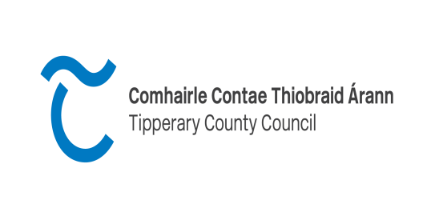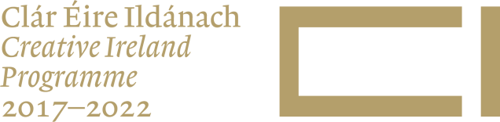

Tipperary Creative Ireland Project Award 2023
Application Form

Name:
Contact details
Email & telephone

Project Title:

Please give an outline of who you are and list those you intend to collaborate with on your project (a CV should be submitted as part of the application and please also provide a letter of support from the group(s).

Category for which application is being made (PLEASE TICK 1)
- €3500-€5000
- €5000-€10000
- €10000-€15000

Please submit a project proposal which refers to the points below:
- How it links to the Creative Ireland Strategy and key themes
- Outline the quality and ambition of your project
- Outline who you are collaborating with
- Outline your target ‘audience’ and who will participate in your project
- Outline the potential benefits of the project to the community/county/participants involved
- Outline your capacity/ability to complete the project
- Please give a detailed breakdown of your proposed budget (Income and Expenditure) for the project including quotations where applicable.

Total project cost
Amount of funding sought?

Please note that if you intend to work with children and young people evidence must be shown of child protection policy in the supporting documentation. Groups/organisations/individuals must be tax compliant and have appropriate insurances in place.
Closing date 4pm Friday 3rd March 2023.

