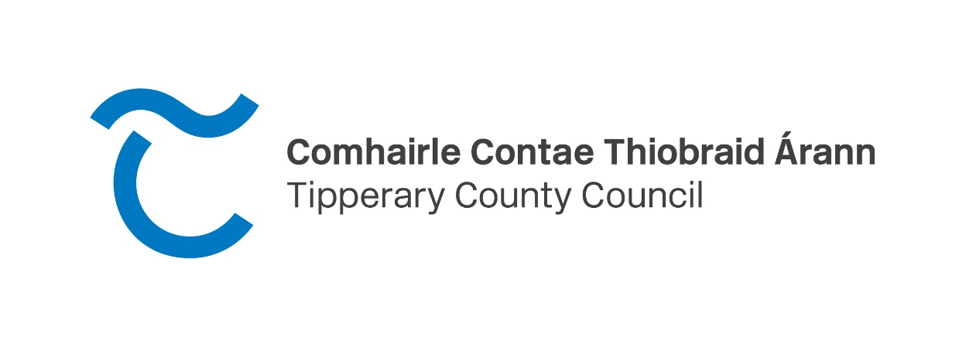

**CALL FOR EXPRESSIONS OF INTEREST IN PRIME 19.2 ACRE INDUSTRIALLY ZONED SITE AT LISBUNNY BUSINESS PARK, NENAGH, CO. TIPPERARY.**

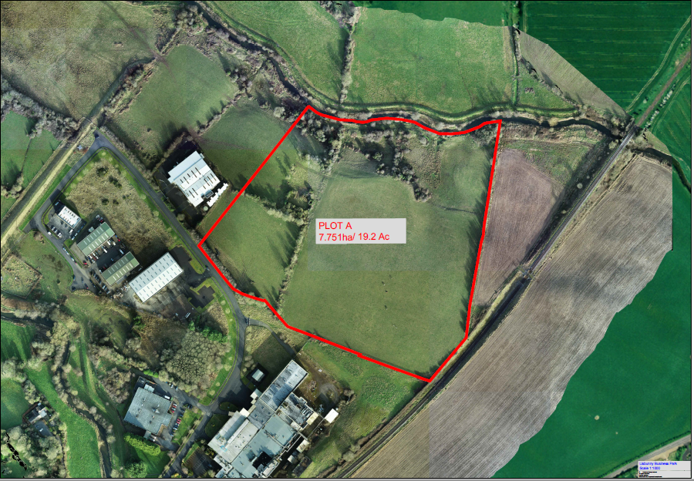

**Background**

The council acquired this land from Shannon Development circa 2020 with the aim of promoting employment and enterprise in the town. Following several enquiries to purchase the land, the council intends to sell the land for creating employment.

This brief is intended to advise interested parties on what the council will require from a purchaser.

**Location**

This site is located at Lisbunny Industrial Estate, Dublin Road, Nenagh, Co. Tipperary. The site extends to 19.2 acres and is prime land ready and zoned for industrial development. The Business Park which has been partly developed, has frontage onto the R445 (Nenagh to Dublin Road) and is situated 1.8km east of Nenagh Town and 2.5 kms west of the M7 Motorway (Junction 24). The site is circa 49km from Limerick, 75kms from Shannon Airport and 85km from Foynes Port.

**Nenagh – An Enterprise Town**

Nenagh has a population of 8,968 people as per the 2016 Census. Nenagh is the 2nd largest town in County Tipperary and is a thriving commercial town. Nenagh is home to many large enterprises such as Carey Glass, Arrabawn Creamery, Abbey Machinery, Quigley’s Bakery, and FiServ a fintech company located at Stereame, Nenagh. The site abuts The Lunch Bag company which has developed a successful operation within the Lisbunny Industrial Estate.

**Folio**

It is registered to Tipperary County Council under Folio TY3301F.

**Planning**

The site is zoned for Industrial use under the Nenagh Town & Environs Development Plan 2013 -2019. Please see Map 1 below showing the Zoning of this development. Policy ZO outlines that it is the policy of the council to ensure that proposals for development conform to the appropriate land use zoning objectives identified in the Plan and the Plan states that the council are “To provide for industrial and employment related development”. Lisbunny Industrial Estate is zoned Industrial.



Map 1. Extract from Nenagh Town Development Plan

**For sale**

In view of the above objective, Tipperary County Council is now willing to dispose of this prime site. The Council is now seeking expressions of interest from interested developers / entrepreneurs who can develop the site immediately and deliver sustainable jobs and economic growth to the town of Nenagh and its wider hinterland.

Tipperary County Council will not sell this land to speculative purchasers. It is being sold for immediate development.

**Process**

**Tipperary County Council intends to undertake a two-stage process. Firstly, expressions of interests will be invited where interested parties can outline a brief project proposal. Successful expressions of interests will be brought forward to Stage 2 where more detailed proposals will have to be provided including the purchase bid for the site.**

**Stage 1:** Interested partieswill submit expressions of interests with a brief project proposal of no more than four A4 pages outlining their proposal to develop the site including the timeframe for completion.

The closing date for expressions of interest will be 4.30 pm on Friday 9th June 2023.

Submissions can be made to Power Property, 51 O’ Connell Street, Limerick, marked for the attention of PJ Power by email to [PJ@ppg.ie](mailto:PJ@ppg.ie)

Submissions must clearly provide full details of the party / applicant submitting the Expression of Interest, including

1. Name of submitting party.
2. Legal Status.
3. Contact Name.
4. Company Name (where applicable).
5. Company Number (where applicable).
6. Correspondence details.

**Stage 2:** Qualified expressions of interests will be subsequently invited to submit a more detailed project proposal for the site. The closing date for this stage will be provided to all qualified parties at the start of Stage 2.

In addition to the purchase bid, and as part of any purchaser’s proposal the following will need to be submitted, and may form part of the decision-making process when deciding on a potential purchaser:

* + Detailed Business Case.
  + Financial Proposal for Site to include how the proposed development will be funded to ensure its successful completion and delivery.
  + Timelines for Planning Application, start of construction, completion date and start of production / activity on site.
  + Proposed Job Creation (i.e. no. of employee’s, average salaries etc)
  + Benefits to the Local Community.
  + Financial consideration that the developer will pay to Tipperary County Council for this site.

Generating employment is a key consideration for the Council hence proposals must clearly outline the expected employment numbers and the benefits your proposal will bring to the area. There is a strong demand for industrial spaces in the town and surrounding hinterland. Proposals must also provide sketches and photo montages outlining in detail the nature of the activity that will take place on site.

The council may use the E – Tenders website to facilitate the submissions for Stage 2 of this process.

**Contact**

For further details, please contact PJ Power, Property Surveyor, of Power Property, 51 O’ Connell Street, Limerick. **P** [+35361318770](mailto:+35361318770)   **E** [pj@ppg.ie](mailto:pj@ppg.ie)

**IMPORTANT NOTICES**

Tipperary County Council does not bind itself to any applicant or Expression of Interest submitted and any Expression of Interest is submitted to, and reviewed by, Tipperary County Council on a ‘subject to contract / contract denied’ basis. Nothing in these particulars or any documentation provided pursuant to same shall constitute an agreement or collateral contract with Tipperary County Council.

Tipperary County Council may decide, at its discretion, to further open the Site to the general market or invite additional proposals by way of further Expressions of Interest or otherwise. Tipperary County Council may end this Expression of Interest process at its discretion and without compensation to any applicant.

These particulars and any documentation provided pursuant to same are provided for the general guidance of applicants only. Tipperary County Council will not be liable for any inaccuracies and no representation or warranty is made in relation to same.

No representation or warranty is made in relation to the condition or suitability of the Property or its services and applicants are deemed to have fully inspected and surveyed the Property prior to submitting an Expression of Interest.

Any and all costs, fees and expenses howsoever incurred by any party preparing or submitting an Expression of Interest are to be considered as work at risk and there shall be no recovery of same from Tipperary County Council. Parties are advised not to make a submission if this condition is considered unacceptable.

The Council is subject to the provisions of the Freedom of Information (FOI) Act. If you consider that any of the information supplied by you is either commercially sensitive or confidential in nature, this should be highlighted and the reasons for its sensitivity specified. In such cases, the relevant material will, in response to FOI requests, be examined in light of exemptions provided for in the FOI Act.

Tipperary County Council reserve the right, but is not obliged, to:

• meet with applicants for the purposes of clarification and / or elaboration of information received as part of an Expression of Interest;

• enter discussions with all or any of the applicants in relation to any aspect of their Expression of Interest.

Any conflict or potential conflict of interest on the part of any applicant (or any of that applicant’s employees, agents, or subcontractors) submitting an Expression of Interest must be fully disclosed to Tipperary County Council as soon as the conflict or potential conflict of interest is or becomes apparent. In the event of any conflict or potential conflict of interest, Tipperary County Council may invite parties to propose means by which the conflict might be removed. Tipperary County Council will, at its absolute discretion, decide on the appropriate course of action, which may in appropriate circumstances include disqualifying a party from submitting an Expression of Interest.

An applicant may be disqualified by Tipperary County Council from this Expression of Interest process if he /she / it:

(a) has been convicted of an offence involving participation in a proscribed criminal organisation, corruption, fraud or money laundering;

(b) has been involved in any activity, criminal or otherwise, which may bring this process into disrepute or;

(c) is involved in any canvassing or lobbying in support of its Expression of Interest.

**Publicity**

No publicity regarding this Expressions of Interest exercise or any contract pursuant to same is permitted without the prior written consent of Tipperary County Council.

**Registrable Interest**

Any registrable interest involving any applicant and Tipperary County Council, members of the Government, members of the Oireachtas, or employees and officers of Tipperary County Council and their relatives must be fully disclosed in

the proposal or, in the event of this information only coming to the notice of the applicant after the submission of a proposal, must be communicated to Tipperary

County Council immediately upon such information becoming known to the applicant.

The terms “Registrable Interest” and “Relative” shall be interpreted as per Section 2 of the Ethics in Public Office Acts 1995 and 2001, copies of which are available at www.irishstatutebook.gov.ie. Tipperary County Council will, at its absolute discretion, decide on the appropriate course of action, which may in appropriate

circumstances include eliminating an applicant from this Expressions of Interest exercise or terminating any contract entered in to by an applicant pursuant to same.

***Data Protection***

“Data Protection Laws” means all applicable national and EU data protection laws, regulations and guidelines including, but not limited to, Regulation (EU) 2016/679 and any guidelines issued by the Office of the Data Protection Commissioner.

Tipperary County Council will be a Data Controller (where Data Controller has the meaning given under the Data Protection Laws) in respect of any Personal Data (where Personal Data has the meaning given under the Data Protection Laws) required to be provided by applicants in response to this Expression of Interest. The applicant, as Data Controller in respect of any Personal Data provided by it in its submission, is required to confirm that all Data Subjects (where Data Subject has the meaning given under the Data Protection Laws) whose Personal Data is provided by the applicant have consented to the processing of such Personal Data by the applicant, Tipperary County Council and the Evaluation Team, for the purposes of the participation of the applicant in this Expression of Interest or that the applicant otherwise has a legal basis for providing such Personal Data for the purposes of its participation in this Expression of Interest process.

**Confidentiality**

All documentation, data, statistics, drawings, information, patterns, samples or material disclosed or furnished by Tipperary County Council to applicants during this Expressions of Interest exercise:

(a) are furnished for the sole purpose of replying to this Expressions of Interest exercise only;

(b) may not be used, communicated, reproduced or published for any other purpose without the prior written permission of Tipperary County Council;

(c) shall be treated as confidential by the applicant and by any third parties (including subcontractors) engaged or consulted by the applicant; and

(d) must be returned immediately to Tipperary County Council upon cancellation or completion of this Expressions of Interest exercise if so, required by Tipperary County Council.