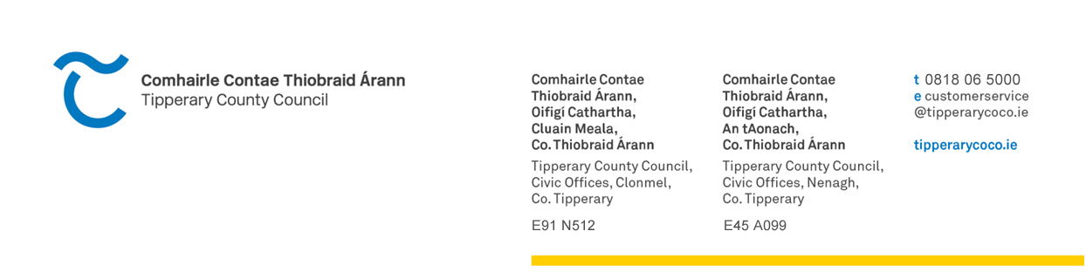 2024 Application Form - Contributions to Residents Association for
Estate Enhancement in the Nenagh Municipal District Administrative Area

Please note that this scheme is for enhancement works such as shrubs, tree planting, erection of estate name plate, enhancement of green area, purchase and maintenance of grass-cutting equipment etc.. Grant is non-transferrable once allocated.

1. Application Details
1.1 Details Of Residents Committee
Name of Residents Committee:

Contact Name for Correspondence: |  |  | Phone: | Fax:
Contact Address for Correspondence: |  |  | Email:  Facebook Page:
Names, addresses and contact numbers of Residents Committee
Name | Position | Address |  |  | Contact No.
2. Outline proposed estate enhancement work to be carried out:-

2.1 Proposed costing

Breakdown of Cost €
Detail
_______________________ _____________________
_______________________ _____________________
_______________________ _____________________
_______________________ _____________________
_______________________ _____________________

Other (please specify):
_______________________ _____________________
TOTAL _____________________

3. Number of Houses in the Estate –

4. Has your Resident’s Association registered with the Public Participation Network (PPN)
Yes No
If not, it is a requirement that you register with the PPN - registration can be done on line at www.ppntipperary.ie or alternatively by contacting 0504 61014
Signatories: This form must be signed by two members of your committee
Name: | Name:
Office held: | Office held:
Address: | Address:
Telephone no: | Telephone no:
Signed: | Signed:
Date: | Date:
Closing date:- Friday 15th March 2024 at 4.30 p.m.

Send completed form to:- Nenagh Municipal District,Tipperary CountyCouncil, Civic Offices, Limerick Road, Nenagh, Co. Tipperary.

Applications should be accompanied by a current bank statement.

Successful applicants will be required to submit the following prior to draw down of any grant:

- Written confirmation of completion of proposed enhancement works
- Before and after photographic evidence of works undertaken
All applicants should note that there will be only two scheduled payment dates for this scheme. Full documentation required must be submitted in advance of these dates in order for payment to be made.Receipt of funding in previous years is no guarantee of funding in 2024. Likewise allocation of funding in 2024 is no guarantee of funding in future years.

