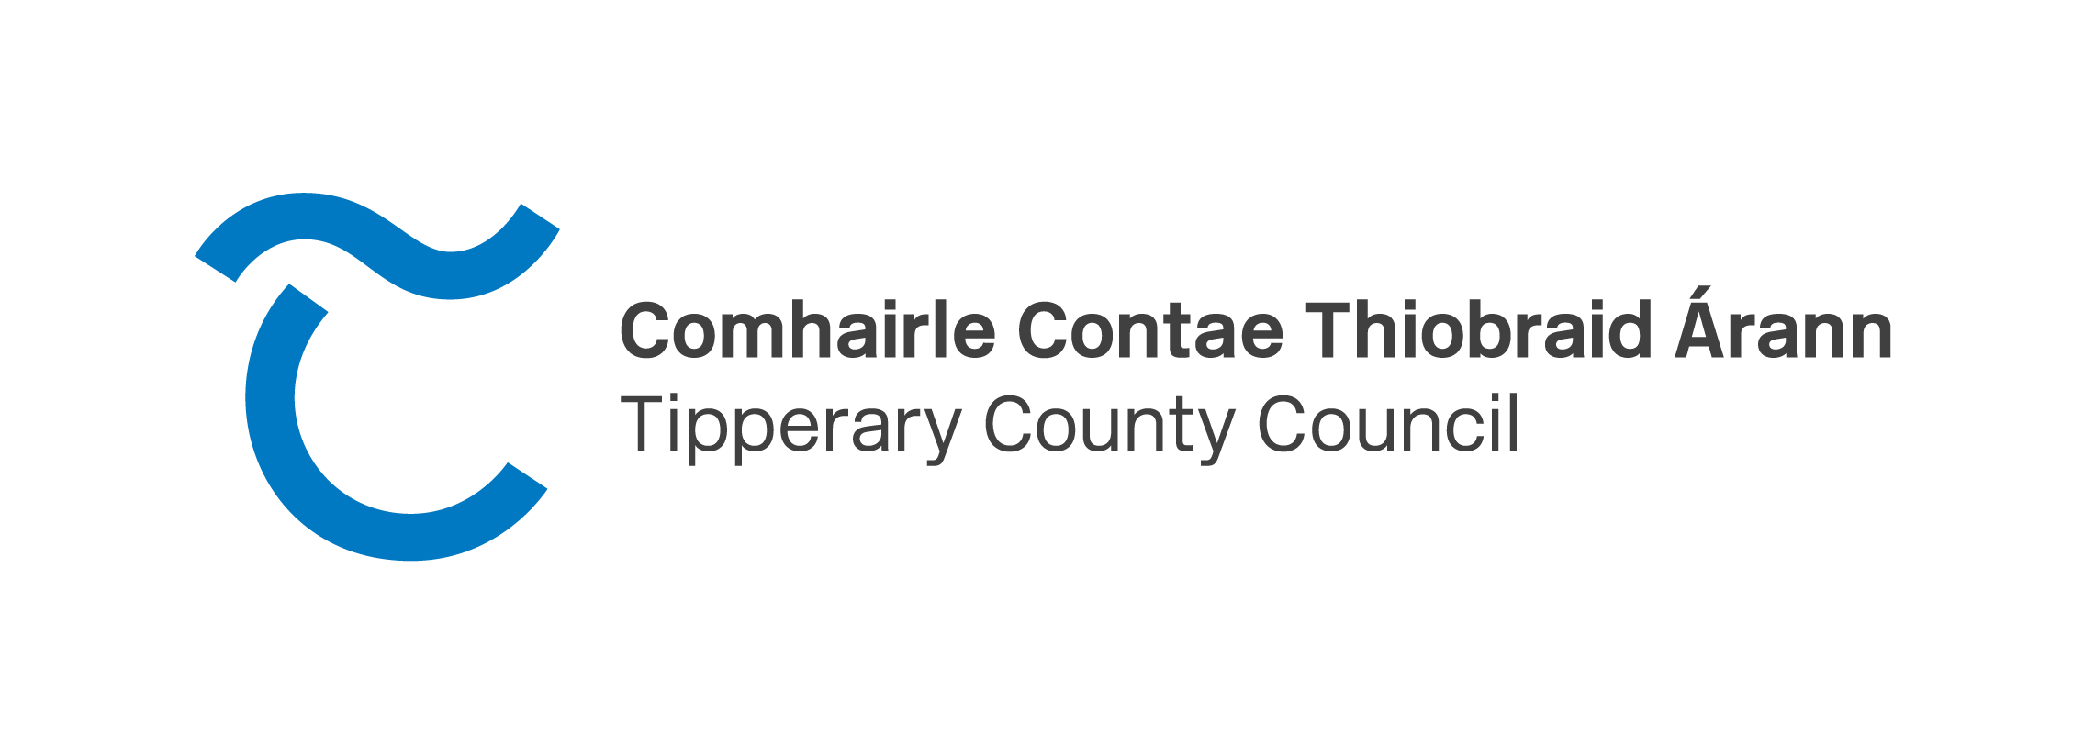
19th of February
Press release - Calls for Expression of Interest for Town Centre First Project Development Supports available to communities
The Town Centre First (TCF) policy is a major cross-government policy that aims to tackle vacancy, combat dereliction and breathe new life into our town centres. It supports “Our Rural Future”, Ireland’s rural development policy which is integral to our national economic, social, cultural and environmental well-being. It advocates for a holistic, place-based approach to sustainable rural development.
The policy seeks to support towns of all sizes, recognising each town is unique and diverse and acknowledges that a “one size fits all” approach will not achieve sustainable and thriving communities.
Recognising that additional supports are required to achieve the TCF policy goals, the Department of Rural and Community Development (DRCD) launched a suite of supports in February 2024 to implement a series of measures for rural communities. Each measure is accompanied by its own eligibility criteria, thereby targeting a number of towns per county.
These measures will compliment other funding initiatives within the Department, including the Town and Village Renewal Scheme and the Rural Regeneration Development Fund.
Tipperary County is required to seek expressions of interest from towns/villages under the Project Development Measure announced by the DRCD.
The purpose of this measure is to assist local authorities to contribute to a pipeline of significant, well developed projects which might be subsequently progressed to construction stage, subject to the availability of further funding. Two applications up to €50,000 in funding each will be submitted by Tipperary County Council to the DRCD for consideration.
Funding may be awarded for costs such as detailed design, planning, procurement, professional fees, assessments and other development costs.
The development of these proposals must be undertaken in consultation with the Town Regeneration Officer in the Local Authority and the local town/village community and business interests. Full involvement by community interests and/or business interests will be an essential feature of successful projects. Ideally, projects will have been identified as part of a town plan, health check or similar study, produced for the town or village. Projects that cannot demonstrate that a consultative process has been undertaken to ascertain the views of local community and businesses will not be permitted.
The Council is seeking expressions of interest forms to be completed and submitted to tcf@tipperarycoco.ie by the 13th of March.
The forms are available on https://www.tipperarycoco.ie/planning-and-building/town-centre-first/town-centre-first-supports
Once the forms are received they will be evaluated. The Council will evaluate all EOI’s received and will decide on two to be submitted to the DRCD along with a completed application form prepared by Tipperary County Council.

