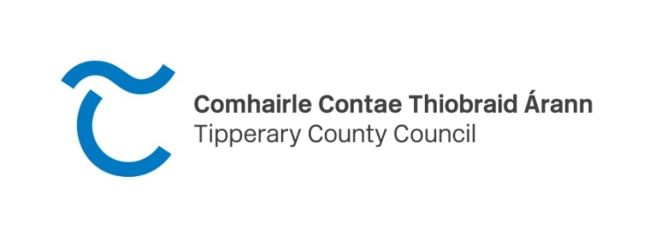
CLÁR 2024
Measure 1: Developing Community Facilities & Amenities
Expression of Interest (EOI) Form
Closing date for EOIs is Tuesday 7th May 2024 at 4.30pm
Please refer to the Department of Rural & Community Development Website for the Scheme outline at 2024 CLÁR Measures
Your project must be located in one of these DEDs to be eligible for CLÁR funding:
South Tipperary
DED ID | DED NAME | DED ID | DED NAME |  | DED ID | DED NAME | DED ID | DED NAME
23091 | Kilmurry | 23123 | Coolagarranroe |  | 23147 | Kilcooly | 23164 | Emly
23092 | Newtown | 23126 | Kilcoran |  | 23149 | Modeshil | 23165 | Glengar
23097 | Clogher | 23128 | Newcastle |  | 23152 | Poyntstown | 23169 | Kilmucklin
23100 | Clonoulty West | 23131 | Tullaghorton |  | 23155 | Ballykisteen | 23170 | Lattin
23102 | Cooleagh | 23136 | Killaloan |  | 23157 | Bruis | 23171 | Rathlynin
23103 | Drangan | 23141 | Ballingarry |  | 23158 | Cappagh | 23172 | Rodus
23107 | Graystown | 23142 | Ballyphilip |  | 23159 | Clonbeg | 23173 | Shronell
23118 | Ballybacon | 23143 | Buolick |  | 23160 | Cullen | 23174 | Sologhodbeg
23119 | Ballyporeen | 23144 | Crohane |  | 23161 | Curraheen | 23175 | Templeneiry
23120 | Burncourt | 23145 | Farranrory | 23162 |  | Donohill
23122 | Clogheen | 23146 | Fennor | 23163 |  | Drumwood
North Tipperary
DED ID | DED NAME | DED ID |  | DED NAME |  | DED ID | DED NAME |  | DED ID | DED NAME
22005 | Aglishcloghane | 22019 |  | Rathcabban |  | 22043 | Kilnarath |  | 22065 | Foilnaman
22006 | Ballingarry | 22020 |  | Redwood |  | 22046 | Latteragh |  | 22066 | Glenkeen
22007 | Ballylusky | 22023 |  | Uskane |  | 22050 | Templederry |  | 22067 | Gortkelly
22009 | Carrig | 22024 |  | Abington |  | 22052 | Borisnafarney |  | 22072 | Longfordpass
22010 | Cloghjordan | 22025 |  | Aghnameadle |  | 22053 | Borrisnoe |  | 22074 | Moyaliff
22011 | Cloghprior | 22028 |  | Ballygibbon |  | 22054 | Bourney East |  | 22076 | Moyne
22012 | Clohaskin | 22029 |  | Ballymackey |  | 22055 | Bourney West |  | 22078 | Templetouhy
22013 | Finnoe | 22036 |  | Dolla |  | 22056 | Killavinoge |  | 22081 | Upperchurch
22014 | Graigue | 22040 |  | Killoscully |  | 22057 | Killea |  | 22701 | Greenhall(037)/ Lackagh(045)
22016 | Lorrha East |  | 22041 | Kilmore | 22058 |  | Rathnaveoge
22018 | Mertonhall |  | 22042 | Kilnaneave | 22060 |  | Timoney

Please note: It is important that this Form is completed fully and accurately and that any additional/supplementary information required is also supplied at the time of submission.
Project Information
Facility/Project Name:
Community/Voluntary Group /School/Local Authority Name:
Contact Person:
School Roll Number if applicable:
Contact Address:
Contact Mobile Number:
Contact Email Address:
Eircode of proposed works
DED Name:
DED ID Number:
NB must be from list on page 1 of eligible DEDs
Is project located in a Natura 2000 site (SAC/SPA) (Y/N).
[Check here ] If yes, has an Appropriate Assessment* per Habitats Directive been completed *See OPR Practice Note PN01 www.opr.ie
Detailed Description of works proposed:

Rational/need for the works:

- Outline how many of the Sustainable Development goals this project will deliver upon?
See https://www.un.org/sustainabledevelopment/sustainable-development-goals/

- Outline how this project will positively deliver on each of the Sustainable Development Goals you highlighted in A.

- Outline how the project aligns with the County Development Plan, Local Economic and Community Plan and the Climate Action Plan

Are these works part of a larger project? (Y/N) - If yes, please provide details
Was an application in respect of this facility submitted and/or approved under CLÁR or any other DRCD scheme in the past 5 years? (Yes/No)- If yes, please provide details.
Are all necessary permissions in place? (Planning permission and required match funding must be in place at the time of application) Attach documentary evidence
Provide evidence of ownership/lease of the facility (lease must be a minimum of 15 year lease for the property)
Confirm with evidence that the facility will be managed, insured and freely available to all members of the community
What are the opening hours of your facility to the public (note school facilities must be open to the public outside school hours)
Demonstrate how your proposal is disability friendly
Total cost of project: |  | €
% Match Funding being provided (minimum 10% of total project cost): |  | €
Provide evidence of the availability of Match Funding
Administration/Professional fees element of funding if applicable (not more than 10% of overall project cost) |  | €
Amount being sought under this CLÁR application |  | €
Attach a full breakdown of the estimated cost attached?
If you wish to provide any additional information to support the application: Please complete the section below or attach separately.

Return completed form by email to CLAR@tipperarycoco.ie with CLÁR 2024 Scheme in subject line or by post to CLÁR 2024, Economic, Community and Rural Development Section, Tipperary County Council, Ballingarrane House, Cahir Road, Clonmel, Co. Tipperary by 4.30pm on Tuesday 7th May 2024

