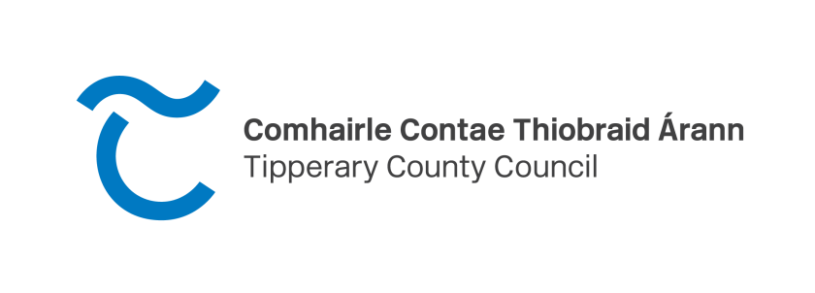
Tipperary County Council is seeking to improve the streetscape and public realm of Towns & Villages in the Nenagh Municipal District through supporting the owners of properties to improve and enhance their properties and public areas generally by such means as, but not limited to:
- Removal of inappropriate contemporary signage, fittings and general clutter and replacement with shop fascia signage (with an emphasis on hand painted signage).
- Painting and general improvements to building frontages.
- Erection of planters, floral hanging baskets or other environmental improvements

Grants of up to 50% of the costs to a maximum of €500.00 are available. Decisions on the funding available will be made on a case by case basis taking into account budget availability and types of work to be carried out (for example the rate of grant for hanging baskets and planting might not be the same as for signage improvements).

As a measure to address vacant premises/dereliction, properties that have been unoccupied/not maintained for a period of time and the proposed works will address these issues and improve the streetscape and attractiveness of the town may receive additional funding. Such applications will be considered on their individual merit.

Where a street or a cluster of premises on a street come together to put forward a proposal based on all the premises in that street/cluster participating in the scheme Nenagh Municipal District will examine how additional incentive can be given to participants.

For the purposes of this scheme a property that is currently vacant will be considered to be commercial if its last usage was for commercial purposes.

Applications are currently being accepted and the following Terms & Conditions apply.

- As the budget for the scheme is limited priority will be given to:
  - Properties which currently detract from the streetscape
  - Commercial Properties
  - Properties which have not previously received funding under this or the Streetscape Enhancement Scheme
- If the proposals involve material alterations, in particular to protected structures, planning permission may be required and the applicant is advised to discuss such proposals with the Planning Authority
- A summary of the works required and/or physical improvements proposed must be included on or with the application form.
- Works not requiring planning permission can commence on receipt of notice from the Municipal District. Works requiring permission cannot commence until a final grant is issued.
- The decision to award a grant rests with Nenagh Municipal District whose decision shall be final. In order to obtain the maximum benefit for the scheme in the event that the scheme is over subscribed, monies will be allocated on a first-come, first-served basis.
- Where the applicant has outstanding liabilities with the Local Authority, the grant will only be approved where the applicant agrees to offset the grant against those outstanding liabilities.
- Where the application is for painting the full building should be painted and a vibrant colour scheme should be considered.
- Where a property has mixed use (e.g. commercial outlet on ground floor and residential overhead) the full premises should be included and the costs for same can be included in the claim.
- Restrictions & Drawdown. Draw down of the grant shall only issue provided the applicant is in compliance with the following;
- A notice of completion to include the applicant name, property address, commencement date and date of completion must be furnished to the Council together with receipted invoices and before and after photographs.
- The grant cannot be reassigned without prior approval of the Local Authority.
- The works are in compliance with the approved details and are subject to final inspection.
- Maximum Grant: 50% of the approved cost of the works up to a maximum of €500.00.
- All work must be completed by 11th October 2024 and receipts submitted by 25th October 2024. Carry forward of grant funding beyond year end will not be permitted.

Closing Date for applications is Friday 23rd August 2024.

All work must be completed by 11th October, 2024 and receipts submitted by 25th October, 2024.

Application form is available on www.tipperarycoco.ie or email customerservice@tipperarycoco.ie for further information or telephone 0818 06 5000.

Completed Application forms and supporting documentation are to be returned by email to: sharon.sheppard@tipperarycoco.ie

or by post to:
Rosemary Joyce, District Administrator
Nenagh Town Centre Enhancement & Painting Scheme
Nenagh Municipal District
Civic offices, Limerick Road
Nenagh
Co. Tipperary

