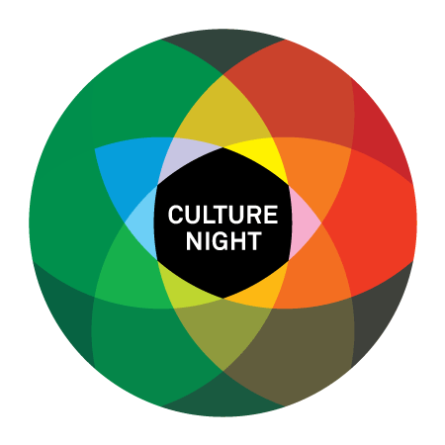**Application Form**

**Tipperary Culture Night Programme**

**Friday 20th September 2024**

**\*Only Events which are free and take place from 4pm onwards are eligible\***

|  |  |  |
| --- | --- | --- |
| **Part A: Details for the Culture Night Website** | | |
| Name of Event | | (Please type in this column) |
| Short Description of Event (40 words)  If you are planning more than one event you can include these details as extra information | |  |
| Is your event a physical event with audiences attending in person, online or a hybrid event? | | In-person Event(s)  Online Events(s)  Hybrid Event(s) |
| Name of Organiser / Organisation | |  |
| Time/Duration of Event (For example 8pm – 11pm) | |  |
| Location/Eircode | |  |
| Public Telephone number | |  |
| Location/Eircode | |  |
| Is capacity limited? | |  |
| Is pre-booking required? If so, please include how to book. | |  |
| Is there disability/wheelchair access? | |  |
| Is the event suitable for children? | |  |
| Will refreshments be served? | |  |
| Website/Facebook/Instagram/Twitter | |  |
| Is this an Irish Language Event? | | Yes No |
| **Activity of Organisation/Individual.**  Tick as many boxes as appropriate   |  |  |  |  | | --- | --- | --- | --- | | **Activity of Organisation or individual** | **Please tick** | **Activity of Organisation or individual** | **Please tick** | | Visual Arts |  | Heritage/Local history |  | | Music |  | Architecture |  | | Literature |  | Theatre Group |  | | Dance |  | Choral Society |  | | Drama |  | Festival |  | | Circus/ Street Arts |  | Club/Group |  | | Traditional Arts |  | Youth Arts |  | | Participatory Arts |  | Venue/Arts Centre |  | | Film/Digital Media |  | Community Organisation |  | | | |
| **Part B: Other Details (these will not appear on the website)** | | |
| Name of Main Contact Person | |  |
| Postal and/or Email Address (for correspondence) | |  |
| Contact mobile No. | |  |
| How many people do you hope will attend the event and how will you keep count? | |  |
| Please give any other details about the event you feel are relevant. | |  |
| **Part C: Application for Funding of an Event Maximum Grant Size: €500** | | |
| Briefly describe the general activities and purpose of your group or organisation. |  | |
| Does the group/organisation have a charity status/tax number? If so please include. |  | |
| Does the group/organisation have a public liability insurance policy in place? Applicants awarded financial support must have a public liability insurance policy in place. |  | |
| How will the event be organised? (For example, is there an organising committee set up? Will you work with the surrounding community? Have you organised a similar event before?) |  | |
| How much funding are you applying for? |  | |
| Please give a full breakdown and description of the costs of your event(s). This must be as accurate as possible.  **(A separate budget sheet may be attached)** |  | |
| What part of the event are you funding from your own resources? |  | |
| Please state how you will promote your event/attract people that do not normally come to the area or take part in cultural events? |  | |
| You may include additional material in support of your application- artist c.v., photos and video links etc.Please list any extra documents here. |  | |
| **For any Group to qualify for Council supports it must register with the** **County Tipperary Public Participation Network (PPN). This will help streamline grant applications and create opportunities for exchange of information.**  If Not, please register now. It will take just a few minutes. **Register at** https://www.ppntipperary.ie/register/  **Or contact 0504-61014** | Please confirm your group is registered with County Tipperary Public Participation Network (PPN):  Yes 🞏 No 🞏 | |
| **Please print name:**  **Signature (on behalf of the applicant):** |  | |

**Please note**

* Please read the corresponding- ‘Culture Night 2024 Applying to hold events in Tipperary- Information Sheet’.
* Access to all events must be open to the public, free of charge and take place **from 4pm onwards on Fri 20th September 2024.**
* Funding will NOT be provided for refreshments.
* Where a grant is allocated to support a particular event or project; Tipperary County Council will NOT be responsible for the insurance of that event or project. Tipperary County Council recommends that event and project organisers ensure that adequate insurance is in place prior to the commencement of any event or project. Groups awarded financial support will have to provide specific indemnity for Tipperary County Council on their Insurance policy in respect of the event(s) and submit to the Arts Office by the deadline specified in letter of offer if application is successful.
* If your funding application is successful, funding will be paid after the event has occurred. Paid receipts must be submitted by early October 2024. (exact date will be confirmed with letter of offer if successful)
* Successful applicants must return a post event report which includes **accurate attendance** figures and images.
* Where a grant is awarded under this scheme, Tipperary County Council will NOT be responsible for the Health and Safety arrangements of that event or project. Tipperary County Council recommends that event organisers ensure that they are compliant with all relevant Health and Safety legislation.
* **Tipperary County Council and The Arts Council must be acknowledged on all promotional material.** Logos will be forwarded to you if successful.

**Deadline: 12 noon Monday 24th June 2024**

**Where to submit Application:**

**Email** this application marked “Culture Night Application” to [artsoffice@tipperarycoco.ie](mailto:artsoffice@tipperarycoco.ie) by 12 noon Monday 24th June **OR**

**Post it to** The Arts Office, Tipperary County Council, Civic Offices, Nenagh, Co. Tipperary **OR**

**Deliver it by hand**: to any of our Tipperary County Council customer service desks (see info sheet for locations) marked “Culture Night Application 2024” and addressed to The Arts Office, Tipperary County Council, Civic Offices, Nenagh, Co. Tipperary.

**Phone:**  The Arts Office on 0818 06 5000 if you have any queries

If you wish to sign up for our Arts Office newsletter and be notified of further Tipperary County Council Arts Office open call/funding opportunities, events of interest and work by Tipperary Artists/groups throughout the county please send an email to [artsoffice@tipperarycoco.ie](mailto:artsoffice@tipperarycoco.ie) with the text ‘subscribe’ in the subject line.

Culture Night **TIPPERARY** is brought to you by the Arts Council, in partnership with Tipperary County Council and cultural organisations throughout the county.

**ONE NIGHT FOR ALL.**

