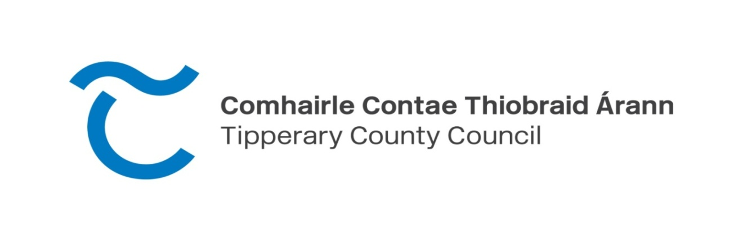

NOTICE PUBLISHING COMMENCEMENT OF AUDIT

Notice is hereby given that the audit of the accounts of the above-named local government organisation for the financial year ended on the 31st day of December, 2023 will be commenced by Fiona Clancy F.C.C.A., Local Government Auditor, on the 26th day of June, 2024. In accordance with article 17 of the Local Government (Financial and Audit Procedures) Regulations 2014, objections to any matter or matters contained in the said several accounts will be considered by the Local Government Auditor during the audit.

Written notice of any proposed objection, setting out the relevant particulars and grounds on which it is to be made, should be sent to the above Local Government Auditor at Local Government Auditor’s Office, Civic Offices, Limerick Road, Nenagh within ten days of the commencement of the audit. The annual financial statement will be available during office hours for the inspection of all persons for a period of seven days before the commencement of the audit.

Dated this 6th day of June, 2024.
Sinéad Carr,
Chief Executive.

